**Decision Analytics for Business and Policy**

Jeff Scanlon

The districts are indexed by *i* = 1,…,36 and *j* = 1,…,36.The regions are indexed by *k* = 1,…,9.The following parameters and decision variables are introduced.

**Parameters**

$$s_{i} = number of net votes won in district i by the Solid party$$

$$h_{i}= number of net votes won in district i by the Hollow party$$

$$n_{ij}= 1 if district i and j are neighbors (contiguous), 0 otherwise$$

**Decision Variables**

$$x_{ik} = 1 if district i is assigned to region k, and 0 otherwise$$

$$x_{jk} = 1 if district j is assigned to region k, and 0 otherwise$$

$$y_{k} = 1 if region k is won by Solid by a margin of 4 votes or more, and 0 otherwise$$

$$u_{ijk} = 1 if districts i and j are both in region k and are contiguous to each other, 0 otherwise$$

Equation (1) defines the objective function as maximizing the number of regions won by the Solid party. Equation (2) sets the constraint that each district must be assigned to only one region and Equation (3) constrains each region to consisting of exactly four districts. Equations (4) and (5) ensure that regions only win (y = 1) if the sum of Solid votes in that region exceed Hollow votes by 4 or more. Equations (6) and (7) ensure that for two districts to be considered contiguous, they must be assigned to the same region, while Equation (8) ensures that these two districts are actually contiguous (neighbors). Equation (9) requires every region consists of at least 6 contiguous relationships (double counting district A as contiguous to B and B as contiguous to A), which ensures all four districts within the region are connected. Statement (10) clarifies that Model 2 is subject to the same objective function and constraints as Model 1.

**Model 1** *– without contiguity constraints*

$max \sum_{k= 1}^{9}{y_{k}}$ (1) $$s.t. \sum_{k=1}^{9}{x_{ik} =} 1 ∀i =1,…,36$$ $\left(2\right)$ $$\sum_{i=1}^{36}{x_{ik} =} 4 ∀i =1,…,9$$ $(3)$ $\sum_{i=1}^{36}{{(x}_{ik}•s_{i}) -{(x}_{ik}•h_{i})≤} 3 + M•y_{k} ∀i =1,…,9$ $(4)$ $$\sum_{i=1}^{36}{{(x}_{ik}•s_{i}) -{(x}_{ik}•h_{i})≥} 4 + M•{(1 - y}_{k}) ∀i =1,…,9$$ $(5)$

**Model 2** *– with contiguity constraints $s.t. { u}_{ijk} ≤ x_{ik} ∀i =1,…,36, , j = 1,…,36, k = 1,…,9$*(6)

${ u}_{ijk} ≤ x_{jk} ∀i =1,…,36, , j = 1,…,36, k = 1,...,9$ (7)

${ u}_{ijk} ≤ n_{ij} ∀i =1,…,36, , j = 1,…,36, k = 1,...,9$ (8)

$\sum_{i=1}^{36}{\sum_{j=1}^{36}{u_{ijk} ≥}} 6 ∀i =1,…,9$ (9)

$* This model has the same objective functions and is also subject$ (10)

$to all four of the constraintsl isted in Model 1.$

**Computational Results**

**Model 1** *– without contiguity constraints*

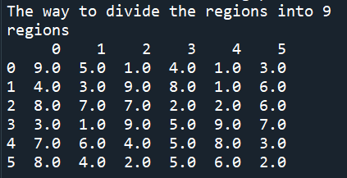

When the contiguity constraints are not imposed, Z* = 8, meaning Solid is able to win 8 out of the 9 regions by 4 or more votes if the regions can consist of disconnected districts. In this example, the only region that is not won by Solid is region #6. All of the other regions lead to Solid winning by exactly 4 votes. This solution requires that all of the districts with the largest Hollow margin (or victory) are coerced into the same region (region #6). This is how the model is able to ensure the Solid margin of victory is large enough in the remaining 8 regions.

**Model 2** *– with contiguity constraints*

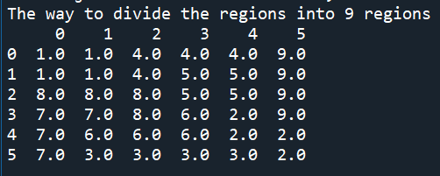

When the contiguity constraints are imposed, only 7 regions can be won by the Solid party, so Z* = 7. The added constraint effectively means that the districts with the largest Hollow victories can no longer be forced into the same region because not all of these districts are contiguous to one another. Our model, instead, creates two regions that absorb the majority of these districts and become regions for Hollow party victory. The 7 regions can be won remaining by the Solid party because their margins are sufficient to overcome Hollow margins. In this solution, regions 6 and 9 are won by the Hollow party while the other 7 regions are won by the Solid party.